His Excellency, 20th February 2012
The President of Federal Republic of Nigeria,
Dr. Goodluck Jonathan
Presidency Abuja.

Mr President,

PROPOSED NEW OIL REFINERY & PETROCHEMICAL COMPLEX AND UREA PLANT;-

Further to the meeting with SENATOR NIMI BARIGHA- AMANGE. We indicated and confirm that Sahara Group U.K s.a, is prepared to undertake the financing and construction of an oil refinery for 500,000 BPD and a petrochemical complex in Nigeria.

We are pleased to confirm that after our meeting we asked in writing to NNPC if they can grant permission to build the oil refinery.

In June 2011 we sent our letter to NNPC and we are awaiting the confirmation from NNPC organization of that. We are hoping to have the confirmation to welcome our group as an acceptable investor to carry out investment in building the oil refinery for 500,000 BPD plus the Petrochemical complex.

With reference to the study; this will be carried out by UOP for the oil refinery part and the complete study will be submitted by the Sahara Group UK. To this end we would appreciate an indication from NNPC of the time for us to submit a full proposal; on receipt of which we will contact the NNPC organization.

The Trans Sahara Gas Pipeline (TSGP) Project

The Trans Sahara Gas Pipeline (TSGP) Project has Multi-National Implications; Nigeria, Niger and Algeria. The SAHARA GROUP applied to undertake this project since 2005; and the group still maintains close contact with Niger and Algeria. From the Nigeria end, there are already existing study groups; however, by virtue of the huge amount involved, the government does not consider it as priority. It looks like a “sleeping giant project”.

We recently undertook an assessment of the Nigerian end of the Trans-Sahara pipeline project, and we have been able to establish from NNPC and the Presidency, the current state of government policy on this project. We understand that Nigeria already has a successful LNG export facility.

Housing Projects

Following productive talks with our office in Nigeria we are delighted that SENATOR NIMI BARIGHA- AMANGE has allowed us to present our proposal to construct from 30,000 to 200,000 affordable accommodation units throughout NIGERIA. It is evident that both our organisations have similar business ethics which will enable us to operate effectively together.

Our documents give full details how SGH is prepared to invest in these proposals, to enable and facilitate the necessary factory investment required to set-up the plant, machinery and staff to undertake the proposed development in NIGERIA.

SGH will be utilising the building solutions and professional expertise of the Sahara Group that will enable this development to be completed 80% quicker than the traditional construction methods currently used in NIGERIA.
We will be able to employ both unskilled and semi-skilled NIGERIAN workforce, because the building solution is process driven, and is not dependent on a skilled workforce to produce the buildings. We will provide this workforce with

comprehensive training to enable them to have transferrable skills to Middle Management, Supervision, Building, Manufacturing, Factory, Health & Safety and
Building Site Operations. By offering this support, (which is currently not provided by other companies in NIGERIA), we will retain a loyal and committed workforce.

SGH intend to source and procure much of the building materials and services from within NIGERIA to assist the country in generating its own internal wealth.

Power Stations
The Management Team of Sahara Group U.Ks.a is extremely experienced and accomplished in constructing and operating major power plants in many regions of the world. Together with the other international companies, we have constructed and operated over 30,000MW of major power plant installations. The power plants we have constructed and operated range from various types of fossil fuel plants to geothermal and solar based power and also wind power. We can certainly add details of more specific power plant projects we have constructed and operated with a complete full list if you require that.
We are happy to meet with the ministry of energy to find the specific needs since we know that you need more than 15,000 MW capacity throughout Nigeria. We can build up to 4,000 MW capacity in units of 1,000 MW, each plant costing from 1.2 billion to 1.5 billion USD.
All of our current management and construction personnel at Sahara Group U.Ks.a and those additional engineers we will hire for this specific project in Nigeria are top-tier engineers in their respective positions. I assure you that Energy Ministry, and the existing energy groups in Nigeria will be extremely satisfied with the project that we propose to supervise, engineer, and construct.

WE CAN DO THIS BUSINESS AND FINANCE100 %

For this eventual business we do need the Country
to give us the Land to build and deliver the waste to our Plant.
budget@parliament.bg

CAGG/ MCESSA with parent company Masada Resource Group is a competitive and responsible provider of proven and environmentally friendly waste technology solutions.

As a private company, CAGG/MCESSA and Masada Resource Group principals have worked with over 300 local government entities to develop extensive infrastructure operations, including environmental services, cable television, telecommunications, and electronic security.

Over the past 2 years, CAGG/MCESSA and Masada Resource Group management has built and operated over $1.5 billion in assets in 18 U.S. states and seven major cities in the U.K.

In 2011 Masada Resource Group and CAGG Environmental formed a joint venture
to create MCESSA (Masada Clean Earth Solution Saudi Arabia) to develop waste
to ethanol facilities in Saudi Arabia.
Today the company has a pipeline of international waste-to-energy projects in over 40 countries.
This pipeline is supported by the multiple clean energy technologies owned or licensed by Masada and MCESSA.

The CES OxyNol process is a unique and proprietary technology that converts
municipal solid waste and sewage sludge into ethanol or other Biofuels
using acid hydrolysis.
MCESSA's additional waste management technologies include pulp mill sludge-to-ethanol, cellulase enzyme production, plastic and rubber to-Polyfuels,
wind-to-hydrogen power, and municipal solid waste Pelletization.

Masada/MCESSA's principals have invested more than $45 million to date for the
development of patented processes with international protection and for the enhancement of its core process so to serve as a reproducible engineering template.

The company has secured 9 domestic and 60 international patents for its core
process.

The process generates eligible carbon credits for projects located in signatory
countries to the United Nations sponsored Kyoto Protocol.

MCESSA has assembled a team of world-class financing partners, risk mitigation insurers, and vendors for construction, start-up and operation of its facilities.
This team forms the cornerstone of MCESSA's performance assurance program.

The company utilizes an experienced persistent executive team headed by (Chairman) Donald Watkins, (CEO) Dr. Amin Ghanem, Alvin Waters, Calvin Waters and Dr. Lloyd Geddes.
This team along with MCESSA's strategic partners in each project location, carry out the development activities that enable to MCESSA's sustain its competitive advantage in the international marketplace.

CORPORATE OVERVI EW
Donald Watkins, Dr. Amin Ghanem, Alvin Waters, Calvin Waters and Dr. Lloyd Geddes are MCESSA's core team.
The team has an extensive background in environmental services,
and major infrastructure project management.

MCESSA's core CES OxyNol waste-to-ethanol process was proven at industrial scale during WWII.
Four years of testing with the Tennessee Valley Authority (“TVA”) demonstrated
the process’s viability and flexibility.
Twenty-first century updates use off-the-shelf equipment to minimize risk.
Key process systems and hardware are in daily operation in similar applications and have been thoroughly tested at a large-scale demonstration plant.
MCESSA's and its core process have successfully “passed” substantial due diligence by numerous third parties, including:

(1) Environmental regulatory agencies
(2) U.S., U.K. and Swiss engineering firms
(3) Bond underwriters
(4) Engineering, procurement, and construction (“EPC”) contractors
(5) Major equipment vendors
(6) Potential insurance providers.

The CES OxyNol process involves five steps whereby the cellulose in municipal
wastes, in the form of hydrocarbons, are converted into sugar (primarily glucose).
The sugar is subsequently fermented into alcohol, which is denatured to produce
fuel-grade ethanol.

The five steps are detailed on the next two pages.

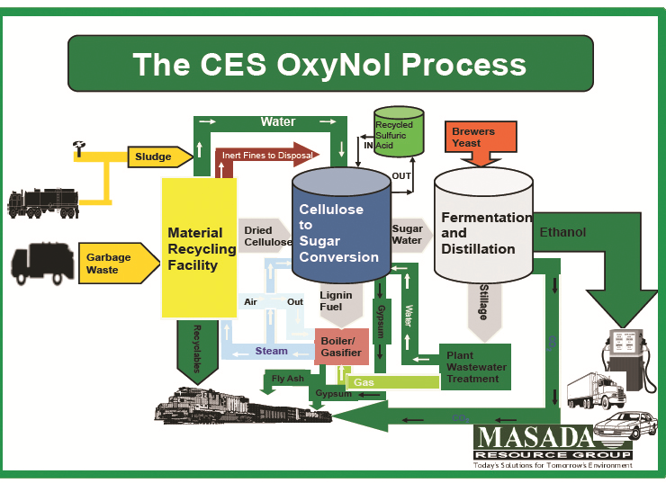

ST EP 1: FEED STOCK PREPARATION

The facility is designed to remove non-cellulosic material from the waste stream.
This creates the cellulosic rich feedstock needed for the chemical reaction during
hydrolysis.

STEP 2 : HYDROLYZATION AND CELLUOSE CONVERSION
Hydrolysis is a chemical reaction that breaks down the cellulose into a slurry
containing sugars, sulfuric acid, lignin and non-hydrolyzed materials.
In the hydrolysis phase, the feedstock is treated with concentrated sulfuric acid which acts as a catalyst converting the cellulose and hemicellulose to glucose and mannose.

ST EP 3 : ACID RECOVERY
A critical element of the OxyNol Process is the recovery of the sulfuric acid utilized
in the hydrolyzation.
The sulfuric acid/sugar solution from the hydrolysis phase is fed into an ion exclusion acid/sugar separation unit to separate the acid and sugar solutions.
The dilute acid solution is reconcentrated through evaporation and is reused in the Process. The sugar solution is transferred to the fermentation area.

ST EP 4 : FERMENTATION
The process design incorporates a traditional batch fermentation process to
convert the sugar to ethanol and carbon dioxide.
During fermentation, the sugar solution recovered from the separation phase is converted to ethanol and carbon dioxide using the biological action of yeast.
The carbon dioxide is collected and processed to commercial standards for resale in an on-site unit.

ST EP 5 : DISTILLATION
Distillation separates the ethanol from fermented mash and water to produce pure
ethanol.
The fermented mash is distilled in a two-phase process.
In the first phase, the ethanol is dehydrated by distillation to approximately 90% concentration (180 proof).
In the second phase, the ethanol is further dehydrated to 100% concentration (200 proof) by using a molecular sieve.
After the ethanol is transferred to a storage tank, it is denatured with gasoline, converting it to fuel grade ethanol.
The denatured product is stored until shipment.

MCESSA's TECHNOLOGIES MEET WORLDWIDE MARKET NEEDS
More than 90% of the municipal wastes are recycled or beneficially reused.
Renewable clean fuel is produced in urban markets where it is needed.
Uncontrolled dumping and burning of waste is prevented.
No “food vs. fuel” issue as with other ethanol production technologies.
There is also no use of arable land.
New “green” jobs for local infrastructure and economic Development is created.

MCESSA's GREEN ENERGY PROGRAM IS READY TO SCALE

OUR REQUEST

SAHARA GROUP, UK would like to open discussions with the Nigerian Government on the Oil Refinery and Petrochemical complex at the highest levels, to have access to the key policy and decision makers, and to ascertain the presidency and/or the government position on this project.

SAHARA GROUP UK s.a is ready, able and willing to finance the project under agreement with the government, to be built on BOT or BOOT, which means we arrange for the construction and the contractors, as well as to arrange for 100%, of the finance of the project. The Oil Refinery and Petrochemical Complex will require sovereign government guarantee on the funding.

The chairman, Sahara Group UK s.a of Companies is ready and willing to have appointment with His Excellency the President to discuss terms and reference to be defined on the agreement for funding and the modality for repayment.

We sincerely look forward to and would appreciate an accelerated response on Government decision that will enable us start discussions with the Government. Please address all correspondence and responses to SAHARA GROUP UK as indicated here, but should be sent through the indicated emails:

Yours faithfully,

Mohammed M. ELSayed Hawas
Chairman
Sahara Group UK s.a
mh@saharagroupu.eu

Nigeria office

MR. Abdulrauflb
Abdulrauflb7@gmail.com or alabi022000@yahoo.com

Telephone numbers:
08035662382 or 07057572580

MR. Bashir.Madigawa

al_bash2003@yahoo.com

